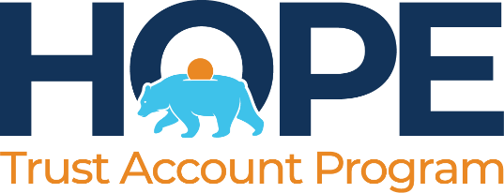

CA HOPE for Children Trust Account Program Board (HOPE)
915 Capitol Mall, Suite 170
Sacramento, CA 95814

NOTICE OF INTENT TO AWARD

Request for Proposals No. HOPE01-25

Consulting Services for the Development of a Financial Literacy Program

April 27, 2026

Notice is hereby given that the CA HOPE for Children Trust Account Program Board intends to award Agreement No. HOPE01-25 to MyPath for Consulting Services for the Development of a Financial Literacy Program.

The last day to protest this award is May 1, 2026.

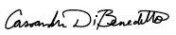
Cassandra DiBenedetto,
Executive Director

